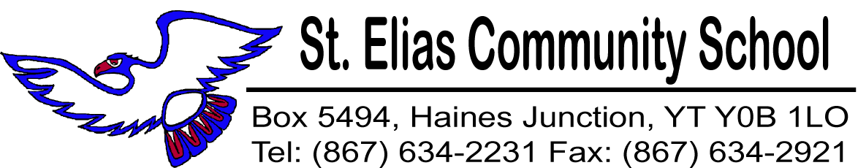

May 14, 2015

We would like to remind parents and students of a few important dates and events coming up this month.

Spring Concert: The SECS annual Spring Concert is this evening at 7:00 p.m. at the Convention Centre. Come on out and enjoy the show filled with amazing talent. Donations will be gratefully accepted at the door. Proceeds go towards future band activities and equipment. See you there!

Vanier Run: We want to wish good luck to runners who will be participating in the Vanier Run tomorrow. Enjoy your day in the sun!

Victoria Day holiday: This coming Monday May 18th is the Victoria Day holiday. There is no school that day.

High School Awards / Cap and Gown: Next Thursday May 21st is our annual High School Awards Ceremony, and the Grad Cap and Gown ceremony at 7:00 p.m. We invite everyone to help celebrate our student’s achievements.

Forestry Trails Run: Don’t forget the annual Forestry Trails Run is on Friday May 22nd. Students will leave the school by bus. Remember to wear sunscreen and a hat, and bring a bag lunch and a water bottle. You can walk or run, and it’s lots of fun!

Graduation Ceremony: We invite the community to join us in celebrating this very important milestone for our Graduating class of 2015. The ceremony begins at 4:00pm on May 25th at the Convention Center.

