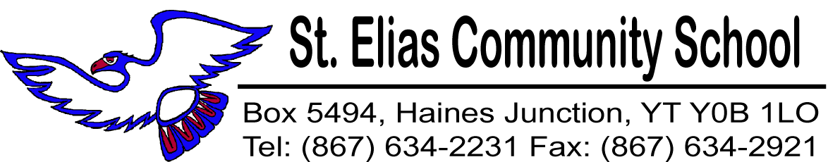

June 13, 2016

Here are a few important reminders for our last week of school.

Elementary Awards Ceremony:
All Parents and community members are cordially invited to attend the St. Elias Kindergarten to Grade 7 Awards Ceremony Tuesday June 14th at 7:00pm in the school gym. It’s time to celebrate the “awesomeness” of our K4 - Gr. 7 students along with their academic growth and accomplishments. We look forward to seeing you at the Awards Ceremony.

Lost and Found Items:
There are many found items of student clothing and such, on tables set up in the hallway by the gym. Please stop by to have a look and take home anything that belongs to your child.

SECS / Community BBQ End of Year Celebration:
Friday June 17th is our last day of school and students will be dismissed at 2:00pm. Report Cards will be sent home with students at the end of the day.

All students, staff, parents and community members are invited to attend a BBQ lunch at 12:00pm. Come and celebrate with us!

June 13, 2016

Here are a few important reminders for our last week of school.

Elementary Awards Ceremony:
All Parents and community members are cordially invited to attend the St. Elias Kindergarten to Grade 7 Awards Ceremony Tuesday June 14th at 7:00pm in the school gym. It’s time to celebrate the “awesomeness” of our K4 - Gr. 7 students along with their academic growth and accomplishments. We look forward to seeing you at the Awards Ceremony.

Lost and Found Items:
There are many found items of student clothing and such, on tables set up in the hallway by the gym. Please stop by to have a look and take home anything that belongs to your child.

SECS / Community BBQ End of Year Celebration:
Friday June 17th is our last day of school and students will be dismissed at 2:00pm. Report Cards will be sent home with students at the end of the day.

All students, staff, parents and community members are invited to attend a BBQ lunch at 12:00pm. Come and celebrate with us!

